

**Lab Manual**

**DATABASE**

**Submitted By:**

|  |  |
| --- | --- |
| Student Name: | Abdur Rafay |
| Student Registration No. | 2024-CS-62 |
| Session: | 2024 |
| Section | B |

**Submitted To:**

Mr. M. Yasir Bilal

Lab Task:

You have just started a new company. It is time to hire some employees. You will need to create a table that will contain the following information about your new employees: firstname, lastname, title, age, and salary.

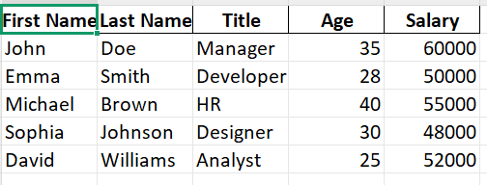

* Find Entity:

The main entity in this case is **Employee** because we are dealing with information related to employees.

* Find Attributes:

Each employee has several characteristics, which will be the attributes:

* **firstname** (First Name) – Represents the employee's first name.
* **lastname** (Last Name) – Represents the employee's last name.
* **title** (Job Title) – Represents the position or job role of the employee.
* **age** – Represents the employee's age.
* **salary** – Represents the employee's salary.

Conclusion:

To store and manage employee details efficiently, we define an **Employee** entity with attributes **firstname, lastname, title, age, and salary**. This structured data can be stored in a database table and used for HR management, payroll, and other business operations.